Plants
Create safer, cleaner, and healthier neighborhoods by planting trees in your yard, on your street, and in your parks, and schools.
Volunteer
Volunteer with us to plant and care for trees where you live, work, and play.
Learn
Learn to plant and maintain strong, healthy trees that will thrive for generations.
Join
Be a part of a movement to bring lasting change to our region, one tree at a time.

Advocate for Trees
Planting 5 million more trees will require help from everyone in our community. There are so many ways to get involved.
You can utilize our NeighborWoods program to ensure that your neighborhood is complete with trees on every street, in every park, on every school campus, and in every yard. NeighborWoods offers expertise and tools for local tree plantings and brings people together to make a difference in their own community.
Help teach others about the extraordinary benefits of trees and how they can plant more trees in their own neighborhoods by volunteering as a Community Planting Leader. Community Planting Leaders are trained to organize and manage volunteers to safely and correctly plant trees at schools, parks, and other public places.
Teachers, parents, Scouts Leaders, and homeschoolers can use our award-winning elementary curriculum, Seed to Seedling, to connect young children to nature. Seed to Seedling guides students and teachers to explore nature in an experiential way. The curriculum complies with California State Content Standards for 3rd and 4th grades.
Learn to plant and maintain strong, healthy trees that will thrive for generations.

Description and Pictures of TREE PLANTING
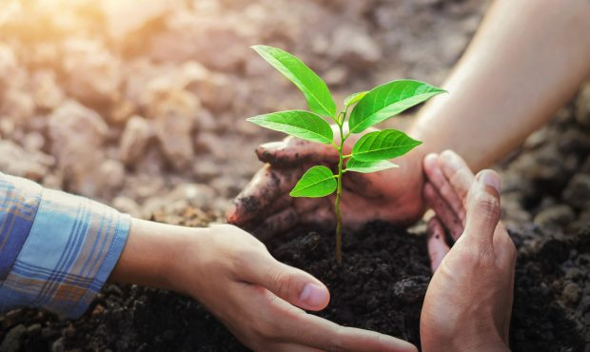
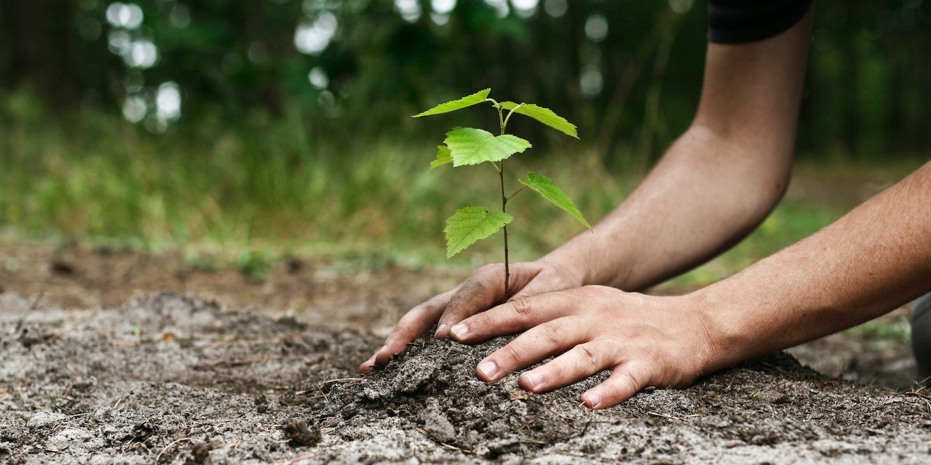
Planting a tree is a lifelong investment. How well this investment grows depends on the type of tree selected and the planting location, the care provided during planting, and the follow-up care after planting. Getting your new tree off to a healthy start will help the tree mature to its full size and ensures it will provide environmental,economic,and social benefits throughout its lifetime.

Green Earth Economy
Humanity is embracing globalization and novel technological solutions, including blockchain and artificial intelligence, BUT at the same time increasing the gap between how we live and the natural universe around US.
Green Earth Economy concept us being created to achieve a viable way to finance solutions to these problems and to empower Earth's Citizens to act individually and together in the inclusive, non-possesive and sustainable manner.
Green Earth is our vision,trademark and a brand and represents Greenn earth Capital and, in a wider global sense, Green Earth Economy.

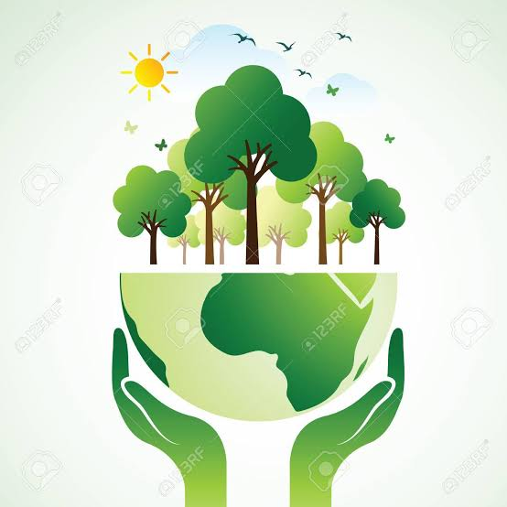
Description and Pictures of GREEN EARTH

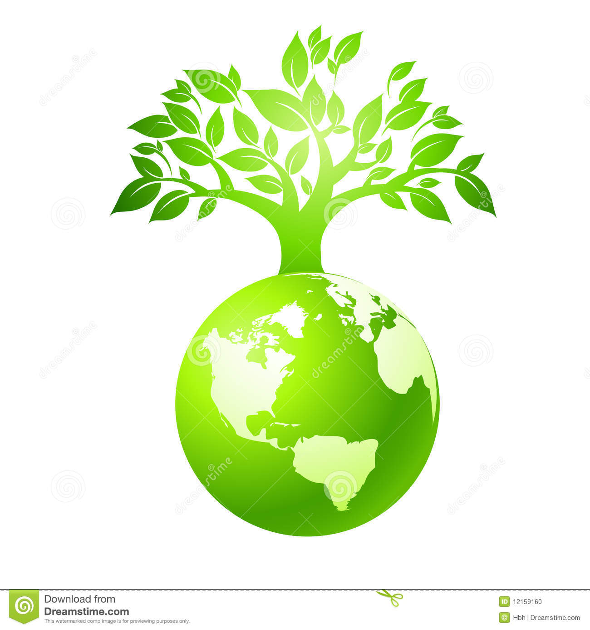

The green economy is defined as economy that aims at reducing environmental risks and ecological scarcities, and that aims for sustainable development without degrading the environment. It is closely related with ecological economics, but has a more politically applied focus.

